SAGA DESIGN PATTERN

We know that when we are developing our project in microservice pattern all microservice are act to each other .
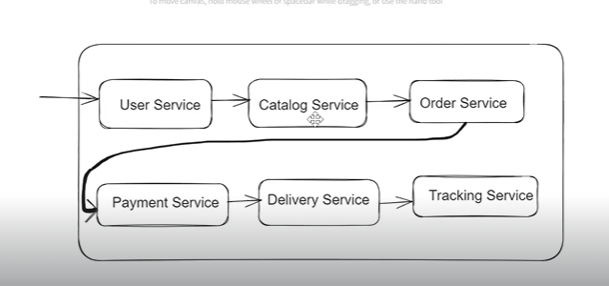

All these microservice involved in the one order purchase .

In Monolithic architecture it is easy to maintain order and transaction commit rollback .but now a days monolithic architecture are using .

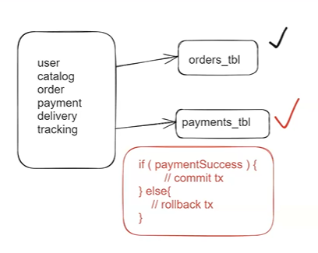

But in the microservice architecture we know that we are maintaing difffernt database for each microservices so it is hard to maintain transaction in between two microservices .

To overcome this problem we are using SAGA Design pattern .

** Saga Is a design pattern used in microservice architecture to manage complex transaction that involve multiple services . In a microservice each service is responsible for its own data and performs a specific business function .

Saga Pattern is an approach to managing distributed transaction that involves braking the transaction into a series of smaller , individual transactions, each of which is handled by different microservice . Each
Individual transaction is executed in a specific order , and the results are stored in a central repository.

Ex : Order service : will place order
Payment Service : will process payment

- First User will place order and will proceed for payment.
- If payment is successful then order should be confirmed else order should be failed .

Note : To Complete user request co-ordinate is required between above services

- As these two services using 2 diff databases managing tx commit and rollback is very challenging.

Note: we need to implement distrbiuted transaction to handle this scenario

### SAGA Design pattern is used to manage distributed transactions in the application.

- SAGA Transaction means sequence of transactions
- SAGA pattern is used to simplify distributed tx management in microservices archtiecture

- SAGA Pattern we can implement in 2 ways
1 ) Choreography (event based)
2 ) Orchestration (command based / controller)

1 ) Choreography
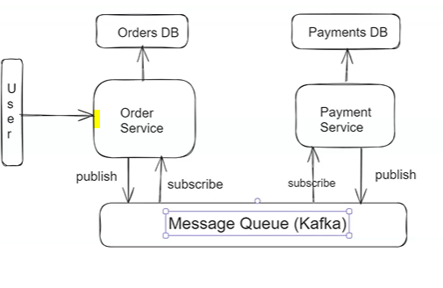
- Event-driven approach: Each service involved in the transaction publishes events and listens to events from other services. There's no central coordinator.
- Flow:
  - The first service performs its action and publishes an event indicating the outcome.
  - The next service listens to that event, performs its own action, and then publishes another event.
  - This continues until all the steps are completed.
- Rollback: If any service detects a failure, it publishes a compensating event that instructs the preceding services to undo their work by performing compensating transactions.
- Example:
  - In an order processing system, once a service confirms an order, it publishes an event that triggers the payment service, which, in turn, triggers an inventory service, and so on.
Pros:
- Simple to implement for small systems.
- Avoids a single point of failure.
Cons:
- Can become difficult to manage with complex flows.
- No central visibility of the entire process.

2 ) Orchestration (command based / controller)

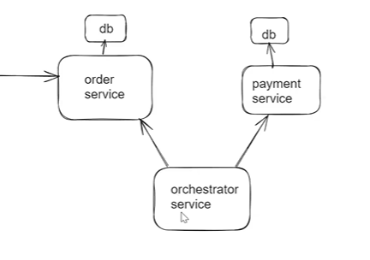
- Central coordinator approach: A central "orchestrator" service controls the Saga by explicitly telling each service what to do and deciding how to handle failures.
- Flow:
  - The orchestrator sends commands to each microservice, telling it to perform its part of the transaction.
  - After each service completes its action, it reports success or failure back to the orchestrator.
  - The orchestrator coordinates compensating transactions if a failure occurs.
- Rollback: The orchestrator is responsible for invoking compensating transactions in the case of failures at any step.
Pros:
- Easier to manage and maintain complex workflows.
- Centralized control provides better visibility and error handling.
Cons:
- Single point of failure if the orchestrator goes down.
- More complex to implement compared to choreography.

